CHECKLIST FOR IEEE IEIR 2025 CAMERA-READY PAPERS

Submission ID: Enter submission ID here Submission type: Full paper / Short paper [Delete as appropriate]

Title: Enter paper title here

Please confirm that your final submission satisfies each of the requirements below. Failure to meet any of these requirements may result in your paper being excluded from the proceedings and/or from IEEE Xplore.
Completed?  (Y/N) | Requirement
 | - The Program Chairs’ and reviewers’ feedback has been thoroughly addressed, with appropriate revisions made to the paper or extended abstract in light of their feedback.( if there is any comment shown in the CMT system)
 | - The IEIR 2025 paper template has been used to prepare the manuscript, and all guidelines stipulated in the template have been strictly adhered to.
 | - Citations and referencing are in compliance with the IEEE Citation Reference guide.
 | - Formatting of the paper has been done using the pre-defined MS-Word styles in the template, rather than manually. The paper must use all the predefined font styles, sizes etc. as per the template.
 | - The paper is within allowed page range for the contribution type (6-8 pages for Full Paper, 4-6 pages for Short Paper, 2-4 pages for Work-in-Progress Paper). There are no superfluous blank pages at the end of the document.
 | - Paper size is set to A4. Margins are set to Top = 0.95 cm, Bottom = 2.54 cm, Left = 1.57 cm, Right = 1.57 cm.
 | - Headers and footers are empty (no page numbers, etc.), except for the first-page footer, which contains the ISBN and copyright label as follows: (1) For papers in which all authors are employed by the US government, the copyright notice is: U.S. Government work not protected by U.S. copyright; For papers in which all authors are employed by a Crown government (UK, Canada, and Australia), the copyright notice is: 979-8-3315-7109-2/25/$31.00 ©2025 Crown; (2) For papers in which all authors are employed by the European Union, the copyright notice is: 979-8-3315-7109-2/25/$31.00 ©2025 European Union; (3) For all other papers the copyright notice is: 979-8-3315-7109-2/25/$31.00 ©2025 IEEE.
 | - Any email addresses and URLs within the file are not rendered as hyperlinks (i.e., they must not be blue and underlined)
 | - The title of the paper is in Title Case. Please use the web-based tool at https://titlecaseconverter.com/ to ensure the title is in the correct case. (Select ‘Chicago’ as the style.) The title must not contain any line breaks; if there is a subtitle, it should be placed on the same line as the title, following a colon, in the same font size. The title must not be bolded, italicised, underlined, etc. There should be no full stop at the end of the title, and it should not be in quotation marks.
 | - Abstract begins with the word Abstract in bold and italics, then an em dash (—), then the text of the abstract. No spaces before or after the em dash. The abstract text itself should be in bold but not italicized, and should not contain symbols, special characters or math. Abstract must be a single, continuous paragraph (no manual line/paragraph breaks), and must not be longer than 200 words for Full Papers, 150 words for Short Papers and 100 words for Work-in-Progress Papers. For papers that are Work-in-Progress, the abstract must indicate that this is the case (e.g., “This work-in-progress paper describes a project …”).
 | - Keywords begin with the word Keywords in bold and italics, then an em dash (—), then the actual keywords. Please be specific—do not use generic terms like ‘education’ or ‘educational technology’. The keywords should all be in lowercase (except for proper nouns, e.g., Microsoft Word, and acronyms, e.g., ANOVA), and they should be separated by commas (,), not semicolons (;). There should be no full stop after the last keyword.
- Section headings are in Title Case. Examples:
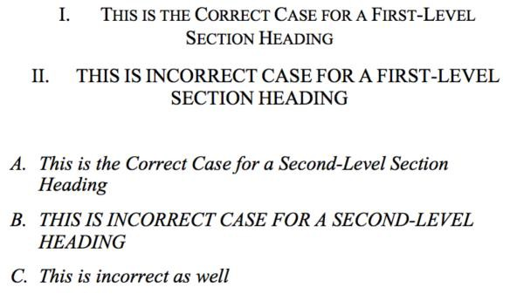
- Table styles are per the template. Table captions appear above tables, not below. Table column headings are in Title Case, and column subheadings are in sentence case. Table footnotes (if any) are right justified. Examples:
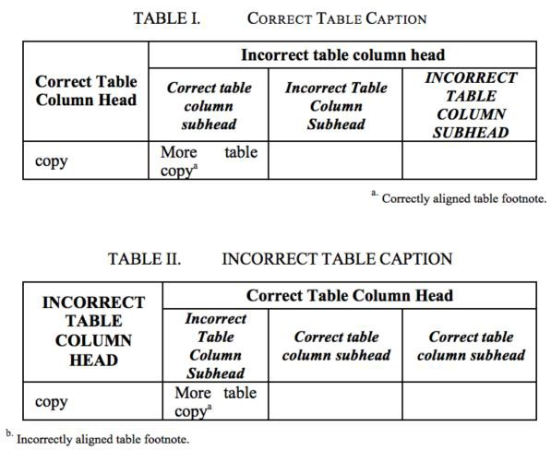
 | - Figure captions must be below the figure, not above. They should be preceded with “Fig. X” (where ‘X’ is the number of the figure), not “Figure X”.
 | - The PDF version of the camera-ready paper has been certified by IEEE PDF eXpress: https://ieee-pdf-express.org/

